1 Contents

1 Contents 1

2 Introduction 2

3 Initial Backend Ideas 3

4 Initial Plan 4

5 Designs 5

**5.1 DESIGN A. . . . . . . . . . . . . . . . . . . . . . . . . . . . . . . . . . . . . . . . . . .5**

**5.2 DESIGN B. . . . . . . . . . . . . . . . . . . . . . . . . . . . . . . . . . . . . . . . . . .6**

**5.3 FINAL DESIGNS. . . . . . . . . . . . . . . . . . . . . . . . . . . . . . . . . . . . . .7**

* Scoreboard Tab
* Team Tab
* Events Tab

**5.4 INTERACTION FLOWCHART . . . . . . . . . . . . . . . . . . . . . . . . . . . 8**

6 Production Plan 6

2 Introduction

I have been tasked in planning, designing, developing, and testing an Esports Scoring system. This software is built for Esports organizers at events and will be used to organize the scores of teams playing matches. It will include features such as a leader board, options to add and remove teams into games and other features that will help the setup team do their job. This document will go through my production process as I design the interface, ask for feedback, develop the software, test the program, and evaluate my application.

3 Initial Backend Ideas

My first idea is to use a database to store all scores and current and previous matches played and to have a user-friendly interface for organizers to understand but enough features for the setup team to take advantage of.

For the interface I may use C# to take advantage of WinForms but I will need to learn C# in the process so that is the only downside of going down this language route.

I could use C++ for this project and use IMGUI as my rendering framework as they have a lot of features for me to take advantage of. The only downside of this is that I cant just drag and drop my buttons and other Interfaces , I will need to hardcode the positions and that will be very awkward to do since I will have to figure out the position of where the on the menu I will want a label, tab or button to be, also I will have to use maths to make sure that the positions will stay relative to the size of the window and also that will add more time into developing it.

My second idea (which will be more easier to implement) is to use a file to store all scores instead of a database and that will be much easier to read the data off of a file instead of setting up a database since I will have to learn databases.

I could also have a database and a file to store data so if something goes wrong you can just import the file into the database. This could be good for backups.

My third Idea is to use Java which I have just recently learned and will use JFrames to render and draw my menu.

4 Initial Plan

I will use Java as my backend and frontend for this project, utilizing JFrames to help design my menu.

I will use AGILE techniques, a common practice in the industry. AGILE isn’t based on concrete timings but are built around sprints where the developers concentrate on jobs. After, they evaluate and can change the estimates or prioritise harder tasks. It encourages evaluation and provides easier management for teams with constant feedback.

The task has given me until the 16th of December to create the project. I estimate that the design will take me a week to create, the development will be 12 days and the testing/optimisation 6 days

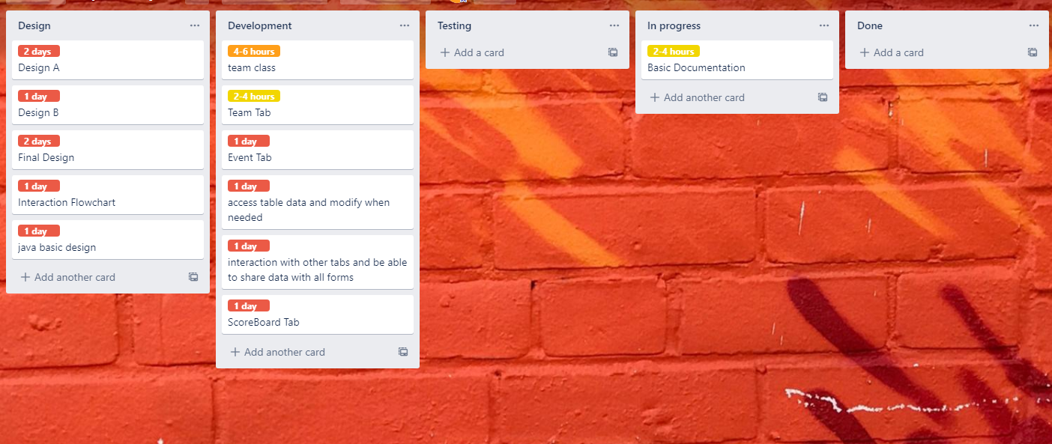

5 Designs

I had two ideas for the design of the program, each being a different layout. I didn’t Know which one was better so I asked two people to give their feedback.

DESIGN A 5.1

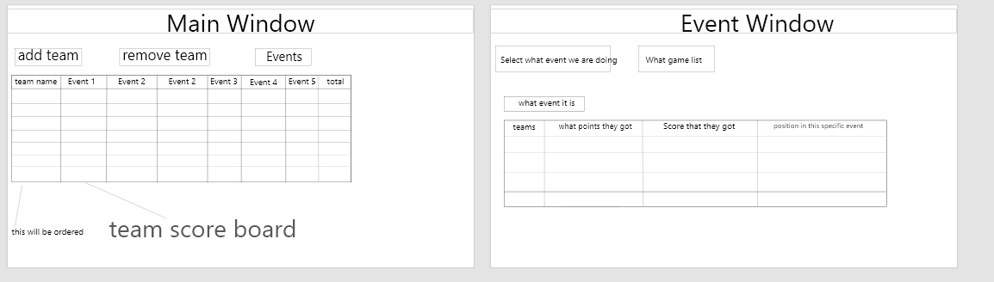

Design A uses Buttons to open up the separate event window. The user will input the scores each team got in that selected event and this will then be added to the main scoreboard. I used this design since it was my first draft and its simplistic to code and isn’t too complicated for the user.

------------------------- **Feedback** -------------------------

+ Both people I asked said it had a good amount of Information and a nice layout

* They also said that the separation wasn’t consistent
* Not aesthetically pleasing
* And said that I could add tabs instead of buttons

DESIGN B 5.2

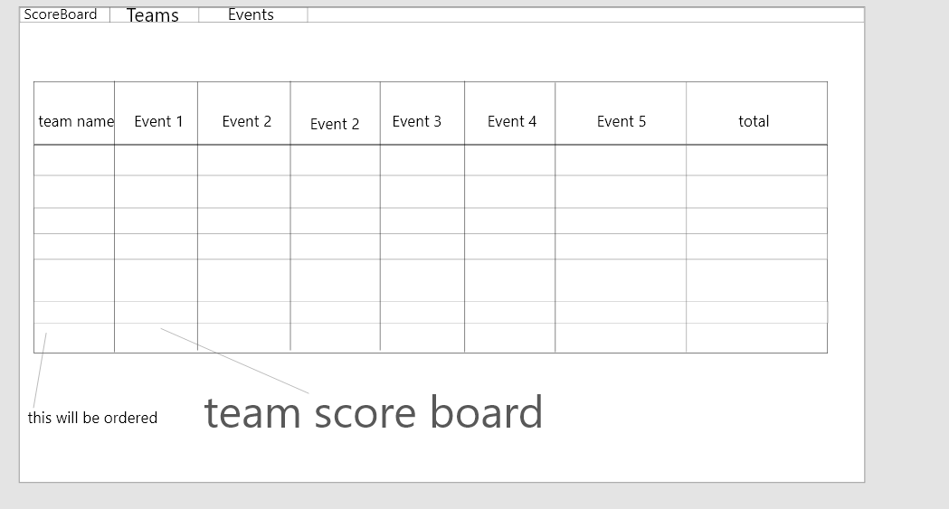

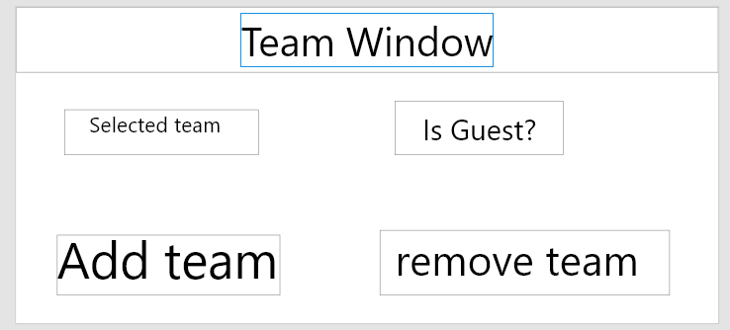

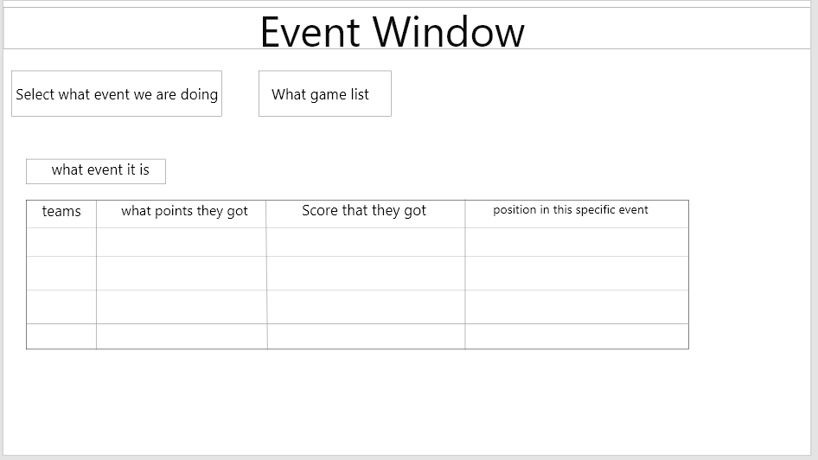

In the second design I added the tabs and made a separate tab for the teams to make it more streamlined

------------------------- **Feedback** -------------------------

**+ This was the Preferred Design.**

+ they preferred the tabs over Design A

+ Aesthetically Pleasing

* They Said that the columns need to be the same size and consistent.
* They also said they there should be a config save system.

FINAL DESIGNS 5.3

In this design it is the draft of the final design, so some labels and stuff will be subject to change.

------------------------- **Scoreboard Tab** -------------------------

I incorporated the tab system and made the spacing consistent and equal.

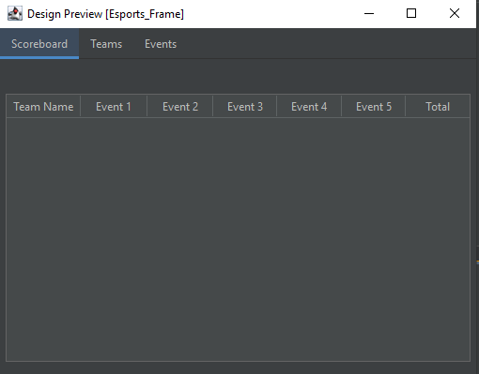

------------------------- **Teams Tab** -------------------------

Team tabs will be subject to change since I don’t really like the sizes but now the scoreboard tab isn’t cluttered with team settings

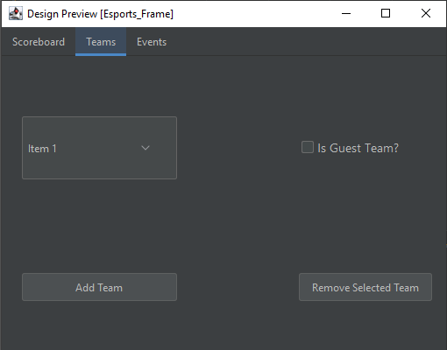

------------------------- **Events Tab** -------------------------

Again, The sizes and positioning is consistent and quite neat. Also font sizes are all the same

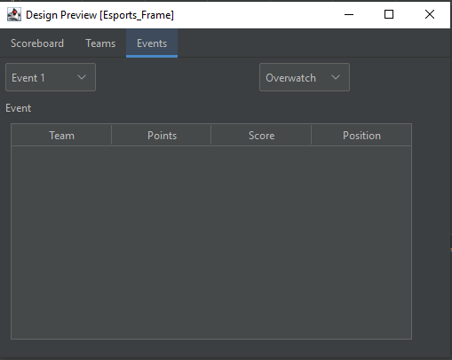

This colour will be changed at the near end of development as to fit with the colour scheme of the college and also the theme may be different. I’m very pleased with this design. The planning and designs have taken me approximately a week.

Tab Interaction Flowchart 5.4

This flowchart is definitely going to change as I will probably have issues with this logic along my time developing this. 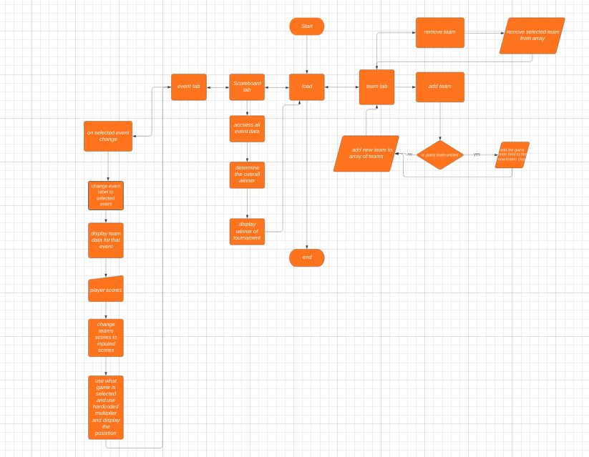

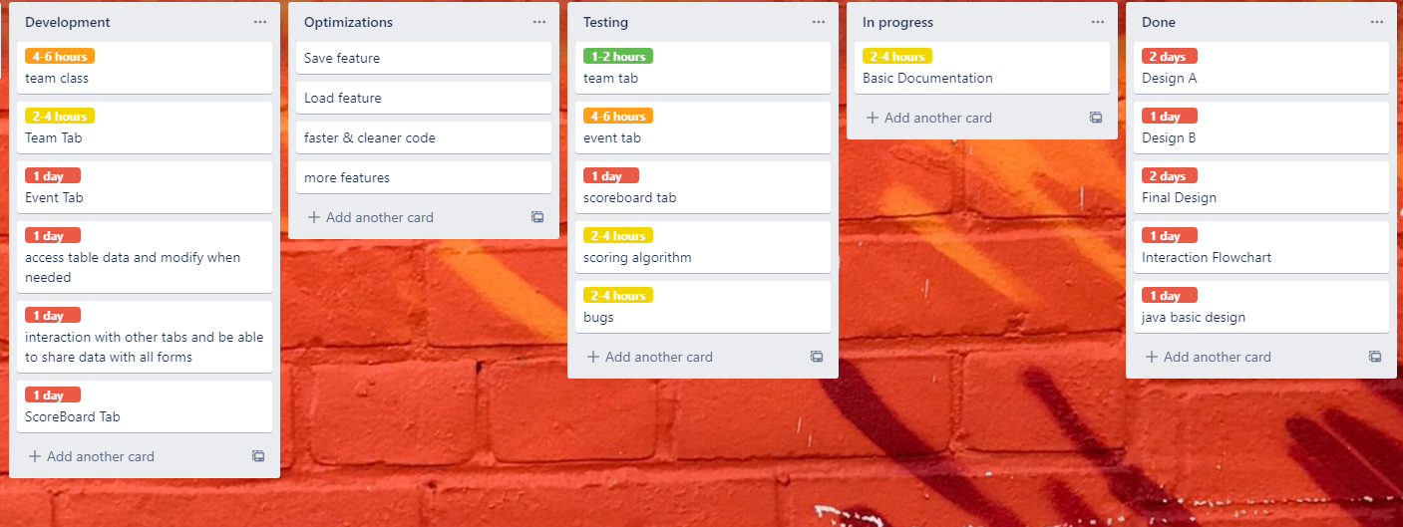6 Production Plan

With my initial designs and final designs completed, I can begin to be more precise with my planning

I have added what I need to test and also what would need to be optimised in the long run.

Also, I’ve added some features that would be nice to add if I have time like the save feature. So, I can save all scores so if it crashes or something happens. you can just load it back up without having to reinput all the data.

The first task I’m going to work on in development is the team class as that will hold all of our data and will be used to pass it to the other tabs.